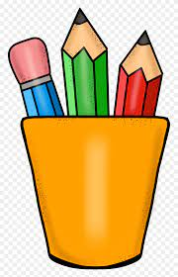

***Fourth Grade Supply List***

Backpack

Pencils

Pencil sharpener

Dry erase markers

Water bottle

Pair of scissors

Box of crayons

Box of colored pencils

Pack of erasers

Headphones

Glue sticks

Folders

Four - single subject notebooks

One - composition notebook

Index cards

***Classroom Supplies***

Box of tissues

Papertowels

Wipes

***Optional***

Box of Markers

Water Bottles